Introduction Data Science
Project 1&2 Report
Spotify Track Dataset & Wikipedia
Group 2
Name | ID | Contribution Report | Contribution code
Hazem Mohamed | 248766 | Q1, Q2, Q3 both Project 1,2  3.Project 2 Project 2 | Q1, Q2, Q3
Omar AbdelRahman | 248229 | Q10, Q11, Q12 both Project 1,2  5. Hypothesis testing Project 2 | Q10, Q11, Q12
Andrew Gad | 243312 | Q4, Q5,Q6 both Project 1,2  Porject1 Recap in Project 2 | Q4, Q5, Q6
Islam Mohamed | 229409 | Q7, Q8, Q9both Project 1,2  Dataset Description Project 2 | Q7, Q8, Q9

Dataset link: https://www.kaggle.com/datasets/maharshipandya/-spotify-tracks-dataset

- Dataset Description
The Spotify tracks is a real world collection with over 114,000 music tracks and have 114 geners, and it was found by the Spotify API via Kaggle. Each track is described by mutipule set of features like popularity, danceability, energy, loudness, tempo, valence, acouticness, speechiness and instrumentalness, also having artist name, track genre and explicit flag. The dataset is used to know how these audio characteristics relate to track commercial success and how they differ across genres.
- Questions
Q1: How do energy and danceability influence track popularity across different genres?
Answer: The chart showed that high energy and high danceability tracks are not necessarily to be the most popular, because the correlation between danceability and popularity was 0.01, and between energy and popularity was -0.023. which means that there is almost no relationship between energy and danceability and popularity.
Insight: that the most popular songs were placed all across the chart. Whether a song had low energy or high, low danceability or high, it still can be popular or not, which means that popularity does not depend on these two features.
Value to the music industry: music producers and artists should understand that making a high energy and danceability tracks does not make it the most popular ones
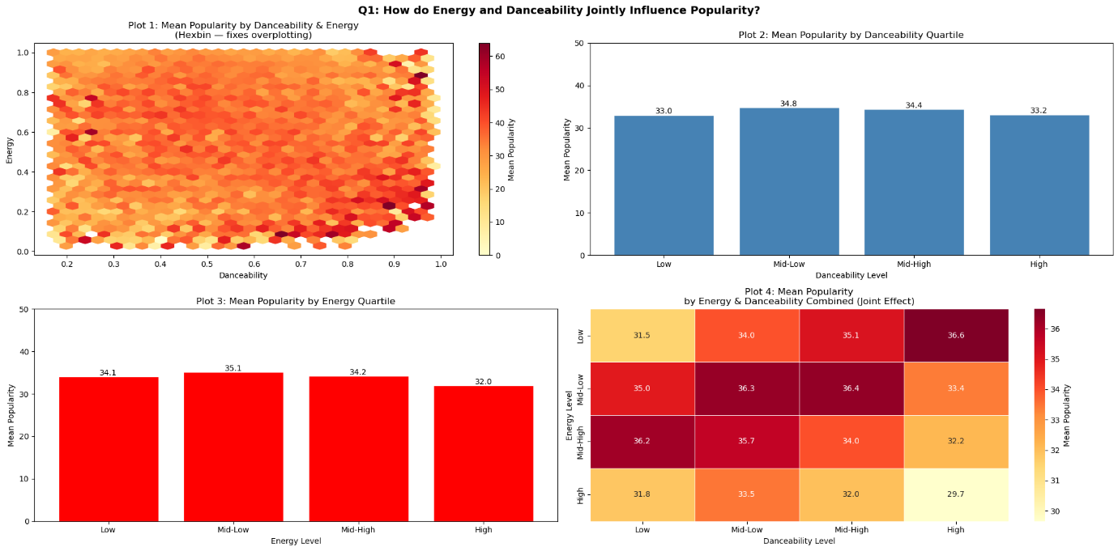
Q2 How does loudness relate to a track's popularity, and does this relationship differ between explicit and non explicit tracks?
Answer: The results show that there is a very week relationship between loudness and popularity for both explicit and non explicit tracks. The line plot shows slight variations across loudness ranges, there is no consistent or strong trend in earthier group.
The correlation values for both groups are eclose to 0, confirming that loudness is not a strong predictor of popularity. Also the boxplot shows that the average and median popularity values are very similar between explicit and non explicit.
Insight: loudness does not affect popularity, and there is no meaningful difference between explicit and non explicit tracks in terms of popularity.
Value to industry: producer should not assume that making tracks louder or explicit will increase popularity, as these factors have a minimal impact compared to other features.
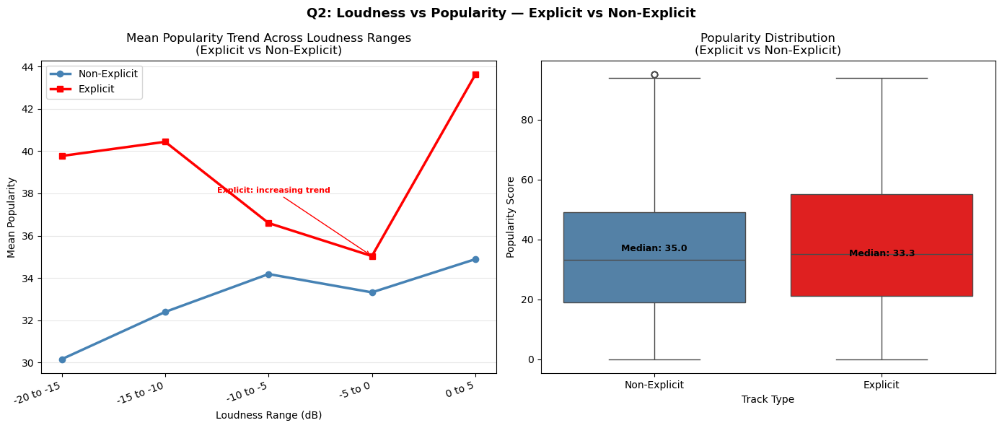
Q3: How does valence vary across genres, and is there a pattern linking happier sounding music to higher popularity?
Answer: the analysis shows that there is no strong relationship between valence which means musical positivity, and genre popularity. While some high valence genres appear among the popular ones, many of the most popular geners dose not have high valence. The correlation between averages valence and popularity is weak. This indicates that happier sounding music is consistently popular than less positive music.
Insight: musical positivity does not determine genre popularity.
Value to industry: Artists should understand that producing happier music will not lead to popularity, as emotions alone is not a strong cause to success.
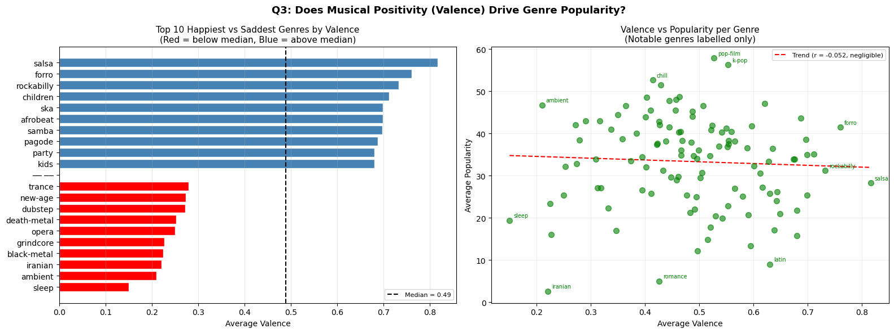

Q4: How does tempo vary across genres, and does a higher tempo correlate with higher danceability and popularity within each genre?
Answer: It was revealed that the fastest tempo songs are not always the most popular or the most danceable. The correlation of tempo and danceability was -0.133 and tempo and popularity is -0.065, it indicates that there is nearly no positive correlation between tempo and danceability or popularity. Genres with the most bubbles (the most popular and the most danceable) included mid-tempo genres (100-130 BPM) such as hip-hop and reggaeton whereas the very high-tempo genres such as drum-and-bass and hardstyle had small bubbles in the lower area of the danceability chart.
Insight: Danceable and popular genres were not on the high end of the tempo range but in the middle of the tempo range. It is a surprise as one could have expected that people feel more like dancing to faster music, however, the chart contradicts it as extremely fast tempo in fact makes it harder to dance, perhaps due to the fact that the tempo is so intense that ordinary dancing is no longer possible. It is also popular in the mid-tempo rather than in high tempo.
Value to the music industry: Music producers must not think that the faster a song is, the more it becomes danceable or popular. It seems that the medium tempo is the golden mean, and the rhythm and the groove should be targeted by artists who want danceability instead of accelerating their songs.

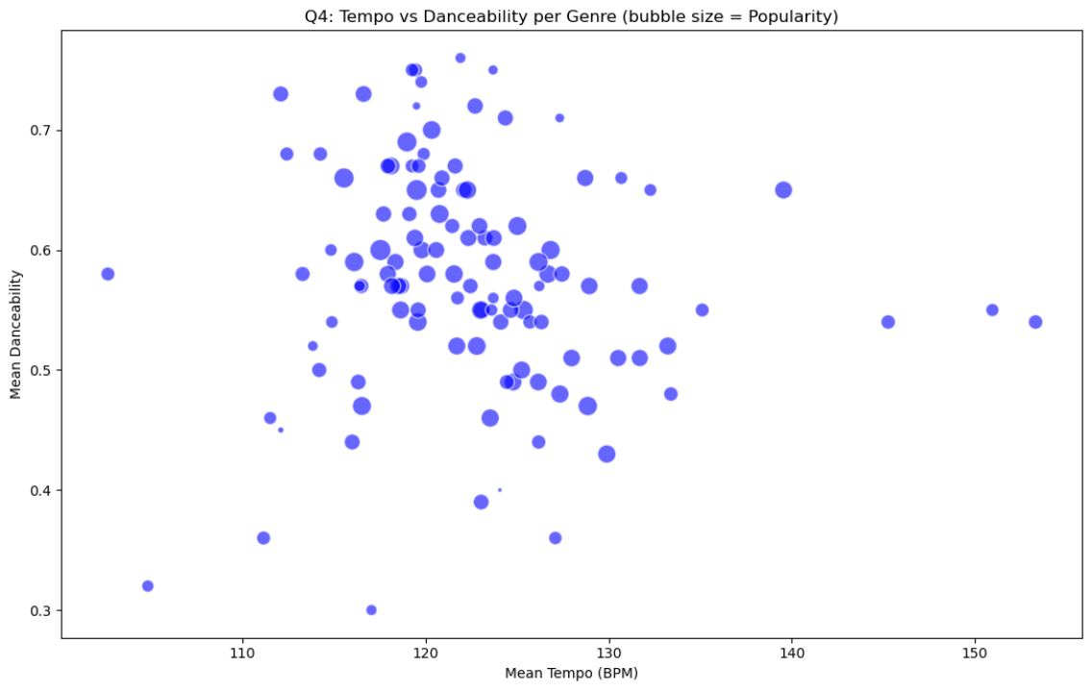

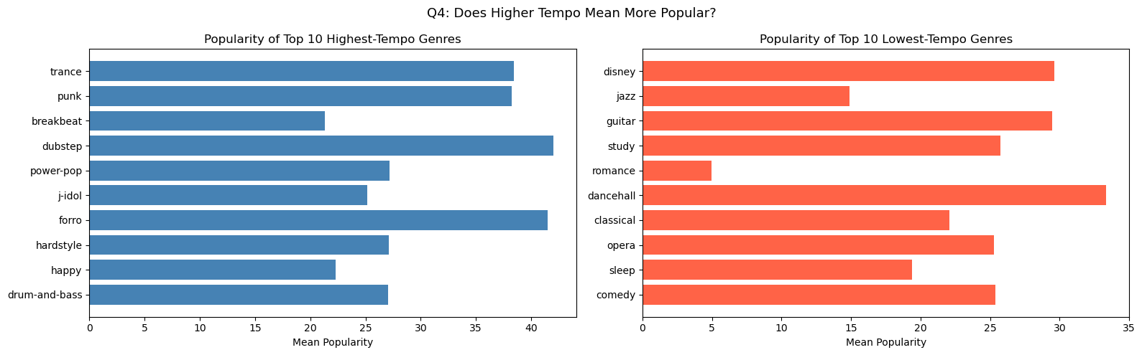
Q5: How does track duration relate to popularity, and are shorter or longer songs more likely to perform well in specific genres?

Answer:
The graph indicated that songs between 2-4 minutes are likely to get the highest marks of popularity, and very long songs greater than 8 minutes almost never get high marks of popularity. Duration and popularity had a correlation of -0.052 which is a very weak negative relationship but it is clear in the scatter plot that very long songs do not become very popular. Such genres as classical, sleep, and ambient were included in the top 10 longest genres, and they are also the least popular.
Insight: Smaller songs obviously dominate in popularity. This is reasonable considering the current trends of listening where the listener is likely to skip long tracks or lose attention. The most long-average genres, classical and ambient, are niche genres that have smaller audiences but are devoted, which is why they have low popularity ratings, despite being rich in art.
Value to the music industry: Producers and artists who want to be popular in mainstream should maintain their songs at the 2-4 minutes range. In the era of streaming where the rates of skip are high, a short and properly structured song is more likely to be played to the end and receive more streams as compared to the long one.

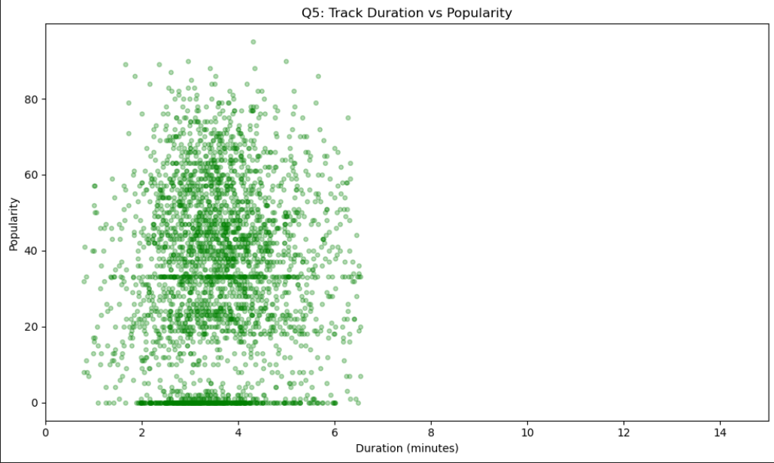
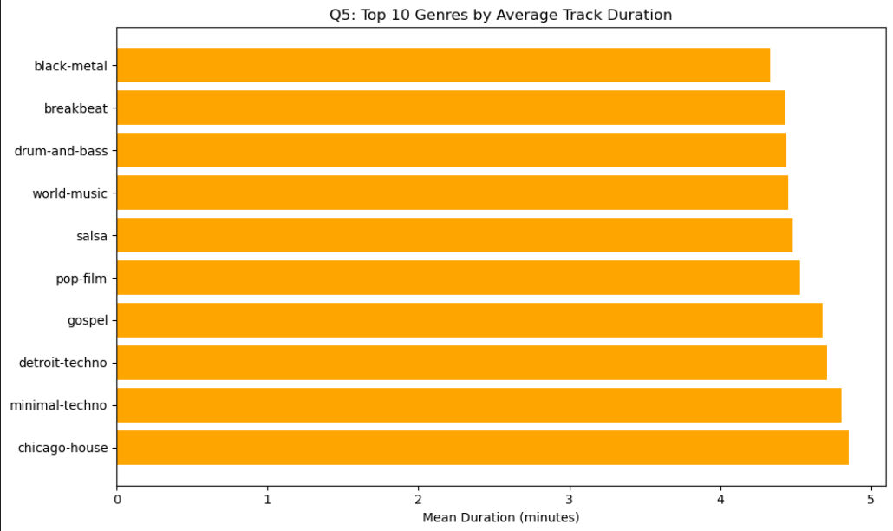

Q6: How does the relationship between acousticness and energy differ across genres?

Answer: The chart was able to demonstrate the strong negative correlation between acousticness and energy among genres. Acousticness and energy had an inverse relationship of -0.845 which is very strong. Such genres as classical, acoustic, and folk were placed on the top-right of the chart with high acousticness and low energy, whereas such genres as EDM, metal, and hard-rock were in the bottom-left with very low acousticness and very high energy.
Insight: This finding supports the fact that acoustic instruments and high energy production are nearly never used in the same genre. The two characteristics are practically opposite to each other, the less rock a genre is the more mellow and less energetic it becomes. This is among the best correlations within the whole data, and this makes acousticness a good predictor of the energy level within a genre.
Value to the music industry: Acousticness can be used as a fast measure of the anticipated energy profile of a track by sound engineers and producers. When a producer is aiming to reach an energetic, club-oriented audience, then cutting the acoustic elements and increasing the electronic or distorted production will be more in line with what the audience would expect in that space.
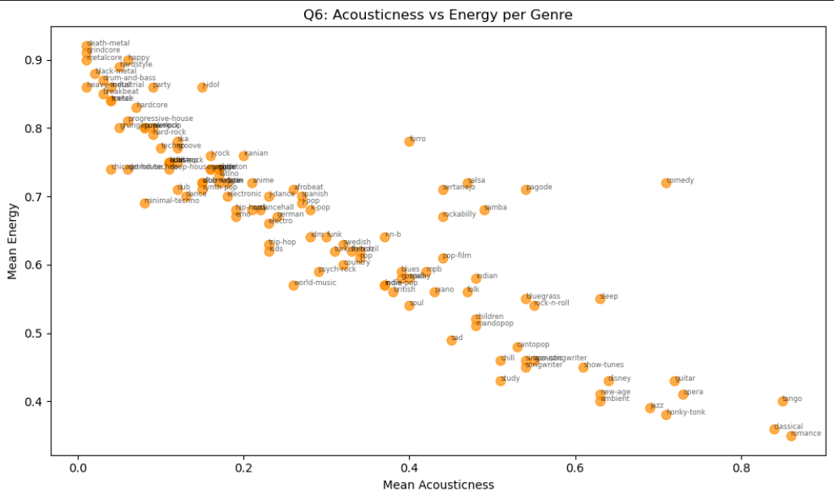

Q7: Genres by Popularity
The top five genres show the most engagement from listeners, demonstrating their dominance in streaming services and popular usage. The five least popular genres typically represent specialized or under-promoted musical forms and have less appeal.

Relevance to the music industry
This enables record companies and producers to focus on profitable genres while simultaneously identifying unsuccessful genres as opportunities for innovation and new trends. This can be used by streaming services to improve playlist organization and suggestions.
Insight:
• The top 5 genres show what listeners are now most interested in; these are probably popular, heavily advertised, and playlist-driven genres.
• The bottom five genres could be less popular, niche, or appeal to smaller audiences.
Value to the Music Industry:
• Producers & Record Labels:
To maximize ROI, especially for commercial releases, concentrate investment on top-performing genres.
• Streaming platforms (like Spotify): To increase engagement and retention, give top genres priority in playlists and suggestions.
• Up-and-Coming Artists: While picking a popular genre might boost awareness, artists can stand out with less competition by entering a low-popularity genre with creativity.
• Strategic Opportunity: Untapped markets may be represented by bottom genres, which may become the "next trend" with the correct marketing.
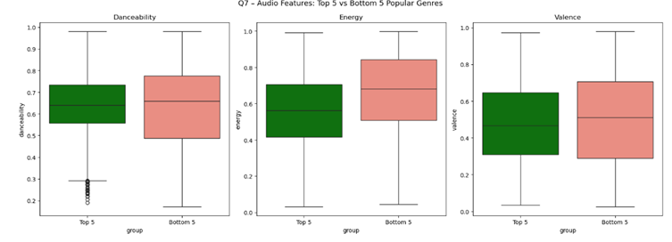
Q8: Speechiness Across Genres
Low speechiness genres emphasize melody and orchestration, while high speechiness genres (like spoken word or rap) emphasize lyrical expression and narrative.
Relevance to the music industry
High speechiness content has a significant impact on branding, storytelling, and social media virality. Platforms can more successfully target consumers who like spoken or poetic content, and artists can interact more deeply with fans.
Insight:
• High speechiness genres, like hip-hop and rap, place a strong emphasis on narrative and lyrical delivery.
• Low speechiness genres emphasize melody, instruments, or vocals without a lot of lyrical depth.
Value to the Music Industry:
• Content Approach:
High-speechiness genres are perfect for cultural expression, storytelling, and music with a message.
• Marketing & Branding: Lyrics and storylines can help artists in high-speech genres develop stronger personal brands.
• Platform Algorithms: Users who interact with spoken-word, rap, or podcast formats can be recommended speech-heavy material by platforms.
• Monetization insight: Because of their quotable lyrics, high-speech songs frequently do well in viral and social media clips.

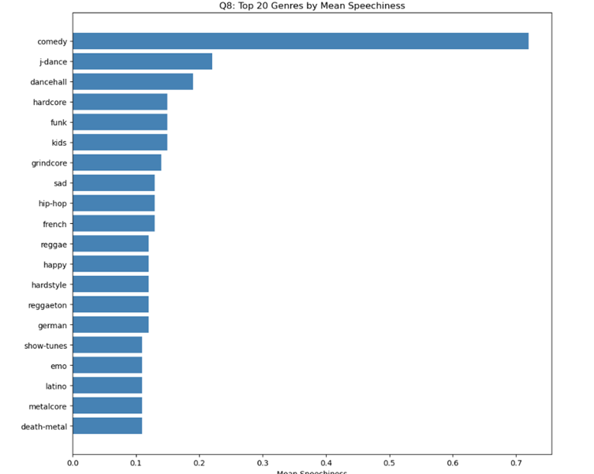
Q9: Correlation Between Audio Features
According to the correlation analysis, popularity is positively correlated with traits like energy, loudness, and danceability, whereas mainstream success may be less correlated with traits like instrumentalness.
Relevance to the music industry
By highlighting popular audio qualities, producers and labels can use this knowledge to create songs that are more economically successful.
It aids streaming platforms in enhancing recommendation algorithms and spotting possible hit songs ahead of time.
Insight:
• The correlation matrix shows the characteristics that affect popularity:
Positive correlations (such as energy, loudness, and danceability) indicate that these characteristics are frequently seen in well-known songs.
o Weak or negative connections (such as instrumentalness) imply that they are less closely linked to mainstream success.
Value to the Music Industry:
• Creating Successful Songs:
Producers can write songs with a lot of energy, danceability, and volume to increase the chances of success.
. • A&R (Artist & Repertoire) Driven by Data:
These connections can be used by labels to find artists and songs that show promise before they are released.
• Playlist Optimization: By utilizing feature correlations, streaming services can adjust recommendations to better suit listener tastes.
• Creative Balance: Although trends are determined by correlations, originality is still crucial because over-optimization runs the risk of making music seem monotonous.

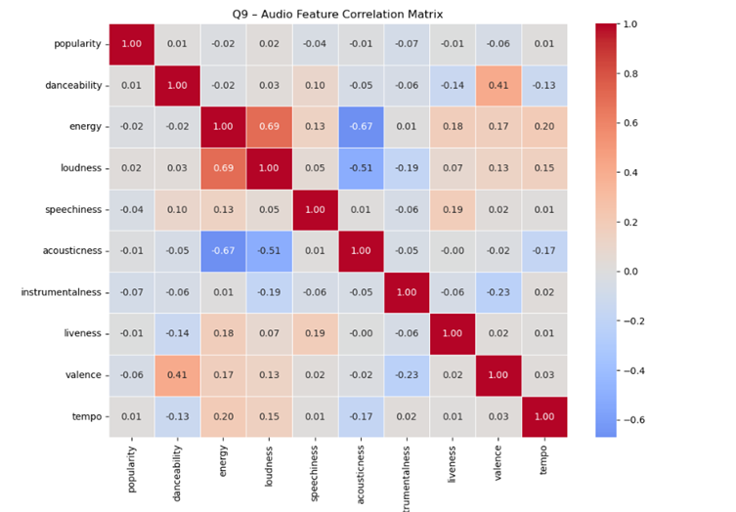

10. How does the proportion of explicit tracks vary across genres, and does explicit content correlate with higher popularity?
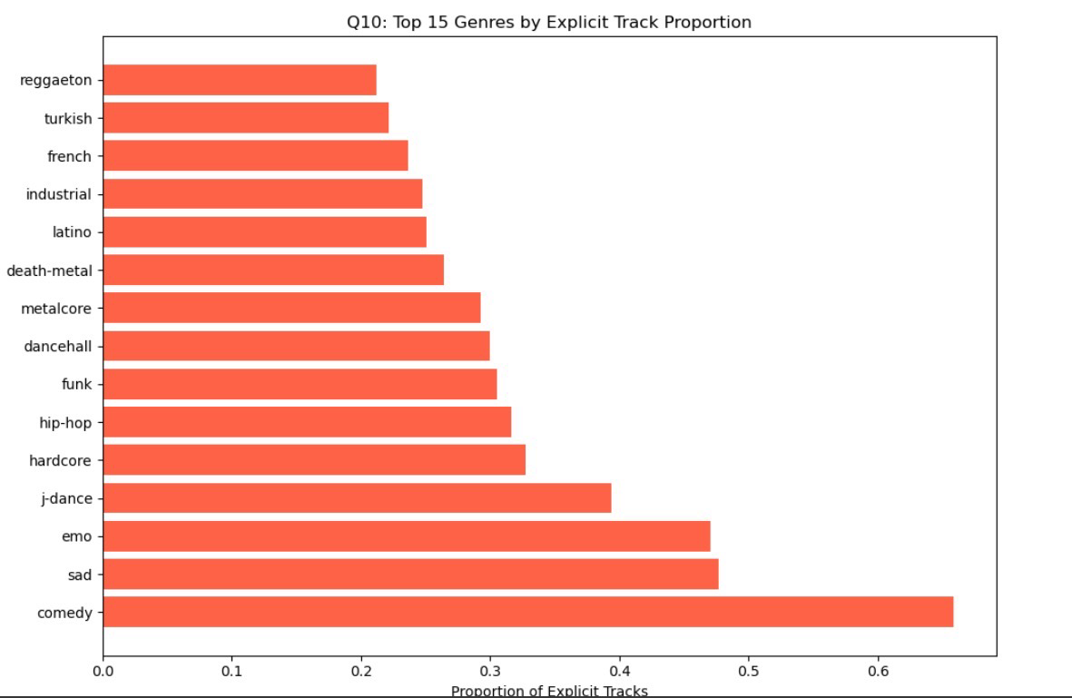
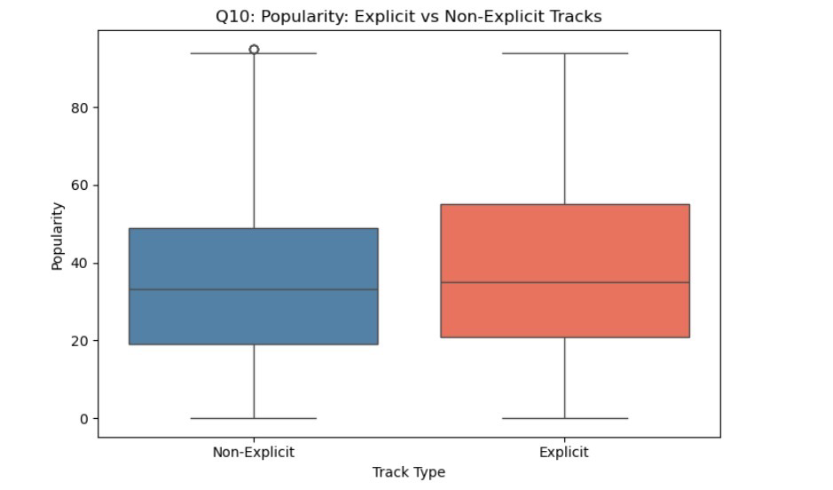
There is a clear division between genres and their relation to explicit content. According to the graph, genres such as comedy, at about 0.64, stand highest, followed by sad at about 0.48 and emo at about 0.47. Mid-range genres such as hip-hop, funk, dancehall, and metalcore fall around 0.30 to 0.35. The lowest proportions appear in genres such as reggaeton, Turkish, and French, at about 0.20 to 0.25.
Does explicitness beget popularity? The boxplot comparing explicit and non-explicit tracks shows a slightly higher median popularity for explicit tracks. Furthermore, explicit tracks display a wider spread, reaching both higher peaks and similar lows.
In clearer terms, explicit content does not guarantee success. It provides a modest advantage in median popularity and increases variability. This would suggest that some explicit tracks may in fact achieve more significant success, while others perform similarly or worse than non-explicit tracks. In plainer terms, explicivness is a gamble that sometimes pays, especially in emotionally intense genres such as emo and hip-hop, although it would not ensure popularity.
11. How do the audio profiles of the top 20 most popular artists differ from those of lesser-known artists?
Feature Top 20 Artists Bottom 20 Artists
Energy ~0.65 ~0.59
Danceability ~0.66 ~0.60
Valence ~0.42 ~0.43
Energy is clearly Higher in top artists and their music is more intense and lively, which makes it more stimulating. Danceability is also higher, as their songs are more rhythmically engaging. The valence, that is to say, happiness, appears nearly identical, if not slightly lower, for top artists.
Popularity appears to depend more on engagement than on emotional positivity. Top artists achieve success through energetic and rhythmically compelling music rather than simply happier tones.
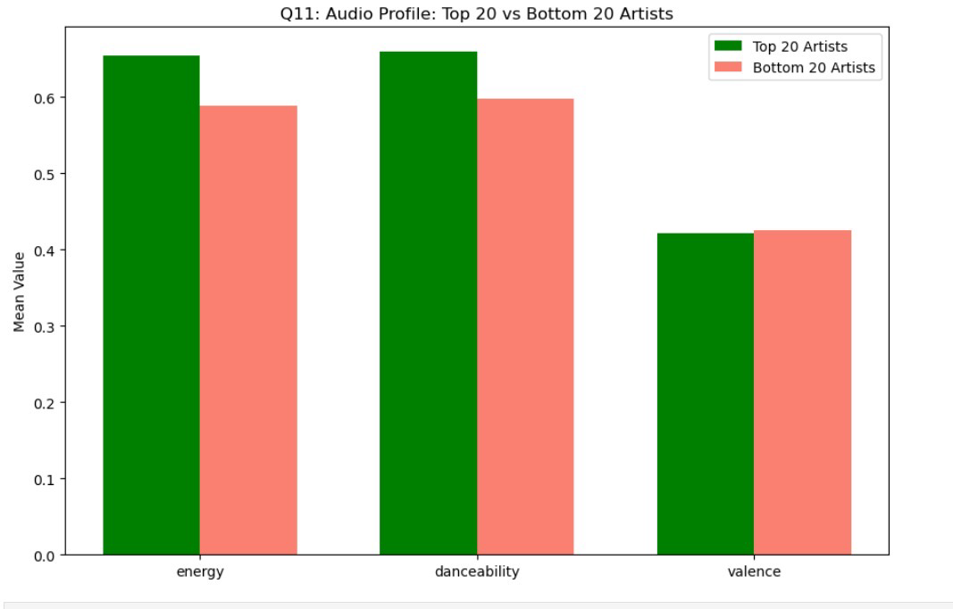
12. Instrumentalness vs popularity across genres
From both the instrumental genre rankings and the scatter plot, a clear pattern emerges. Genres such as study, minimal techno, Detroit techno, IDM, and ambient exhibit very high instrumentalness, between 0.5 and 0.8, yet their popularity is generally moderate to low, roughly between 10 and 35.
In contrast, genres with low instrumentalness, such as pop, hip-hop, dance, and rock, tend to have higher popularity, often ranging from 30 to above 50.
This indicates an overall negative correlation between instrumentalness and popularity. As instrumentalness increases, popularity tends to decrease.
Genres that reward vocal-heavy tracks include pop, K-pop, hip-hop, and dance-orientated electronic styles. These genres combine high popularity with low instrumentalness and rely strongly on vocals. Even within electronic music, styles such as deep house and progressive house tend to outperform purely instrumental techno forms.
Grand Synthesis
Thus, explicitness is a risk-bearing booster of popularity, especially potent in emotionally raw genres. Then audio profile popular artists favour energy & danceability, while emotional tone that is valence matters less. Lastly, the masses favour the human voice over instrumental purity; it may be noble but finds a narrower audience.

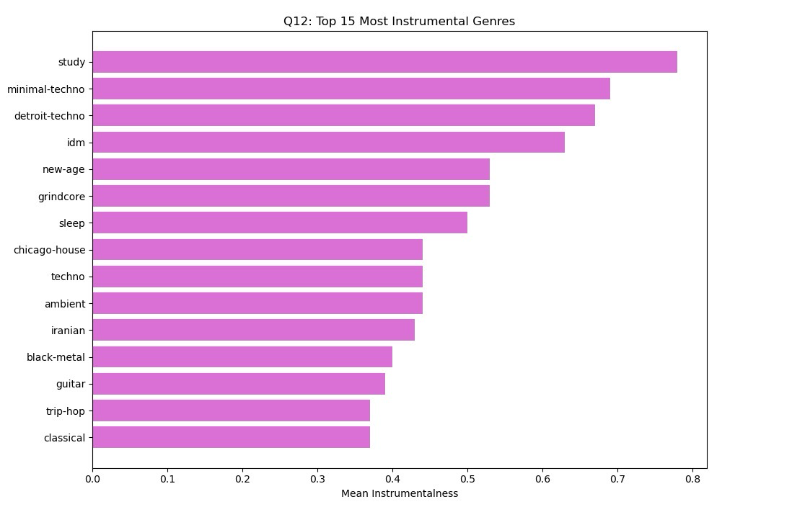

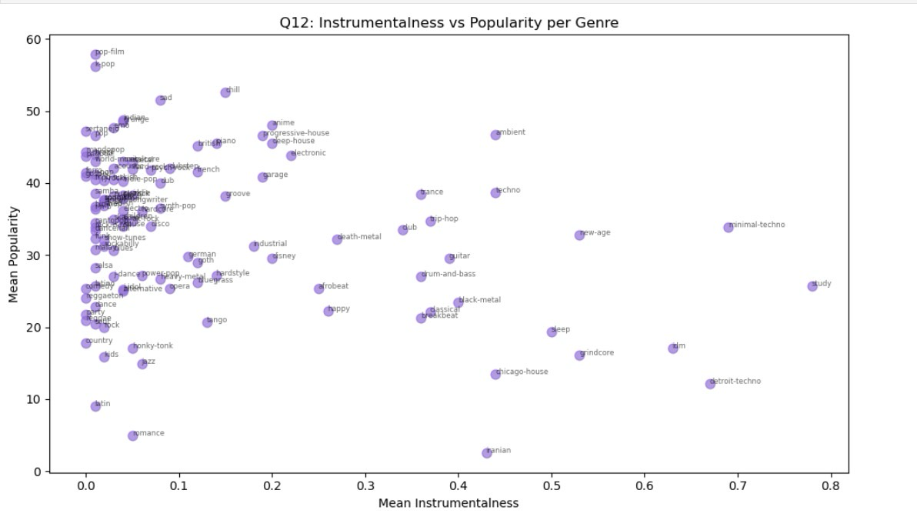

Project 2
1. Dataset Description
Using the Spotify Tracks Dataset, which was obtained from Kaggle. Containing 114,000 rows of track-level data collected from the Spotify API, covering as many as 114 unique music genres. A a single track is represented by 19 columns in each row to capture both metadata like artist name, album, track name, genre and so, and numerical audio features such as danceability, energy, loudness, tempo, valence, acousticness, instrumentalness, speechiness, liveness, and a popularity score that ranges from 0 to 100. We picked this dataset particularly because it allows analysis of both the musical characteristics of tracks and their audience reception across a wide range of genres, what makes it suitable for exploratory data analysis questions about what makes music popular.

Source | Kaggle – Spotify Tracks Dataset
Rows | 114.000 tracks
After cleaning | 100.636 tracks
Columns | 19
Genres | 114 unque genre lables
Additional source | Wikipedia – list of best selling music artist (scraped HTML)

2. Project 1 Recap
Data cleaning steps
We applied the following to prepare the raw Spotify dataset in Phase 1:
• Loaded the raw dataset.csv file that is 114,000 rows, 19 columns
• introduced nulls artificially in 5 columns for the sake of practising null-handling techniques
• Dropped rows where artists, album_name, or track_name were missing
• Filled remaining numerical nulls with the column mean
• Removed 146 rows where tempo = 0 (invalid entries that would skew analysis)
• Converted duration_ms to duration_sec for human-readable output
• Dropped Unnamed:0 and track_id columns (not needed for analysis)
• Removed outliers using the IQR method, approximately 13,000 rows removedArtificially
• Label-encoded the explicit column (True/False to 1/0)
• Label-encoded the track_genre column for use in numerical analysis
• Saved the cleaned dataset as cleaned dataset.csv for use in Phase 2
3. Project 2
3.1 web Scraping steps 1 & 2
To enrich the Spotify dataset with real-world artist information, additional data was scraped from the Wikipedia page titled "List of best-selling music artists" (https://en.wikipedia.org/wiki/List_of_best-selling_music_artists). This page was selected because it contains structured tabular data on the 128 most commercially successful artists of all time — each with their country of origin, the period they were active, their genre classification, and their total claimed record sales in millions. This information could not be derived from the Spotify dataset alone, and adding it allowed the analysis to answer entirely new questions about how geography, commercial history, and career length relate to modern streaming behavior.
Source | https://en.wikipedia.org/wiki/List_of_best-selling_music_artists
Tables | 6 tables
Total artists scraped | 128 artist
Columns ectractid | Artist, country, perio_activity, genre, clamied_sales
New columns | Start_year, years_active
Tools used | Requests, BeautifulSoup, pandas
Now, to cleaning the scraped data, we first removed Wikipedia footnote markers ([10] and [44]) from all text columns using regex pattern \[.*?\] and then simply extracted the first numeric value from claimed_sales "600 million[42]500 million[43]" became 600.0 and also extracted start_year from period_active using regex and computed years_active = 2024 - start_year. That done, came time to normalise genre_wiki column to lowercase with consistent spacing around forward slashes. In addition to fixing merged country names, like "United KingdomUnited States" was split at the lowercase-uppercase boundary to keep only the first country. Lastly, removing 0 duplicate artists and 0 rows with missing key values to have the final shape: 128 rows, 6 columns.
3.2 Data Integration
The cleaned Wikipedia dataset, using left join, was integrated the cleaned Spotify. Extracting the first artist name from the Spotify "artists" column before merging, which stored multiple artists separated by semicolons. pd.merge() employed to merge the first_artist column from Spotify matched against the artist column from Wikipedia. A left join was chosen to preserve all 100,636 Spotify rows, tracks whose artist was not present in Wikipedia would receive NaN in the new Wikipedia columns rather than being discarded. We then had to create a matched_df subset that contains only the 3,094 rows where a Wikipedia match was found, and use it for all Phase 2 analysis questions.
Join type | Left join ( pd.merge, how = (“left”)
Join key | First artist Spotify matched to artist Wikipedia
Wikipedia artist matched | 90 out of 128
Matched_df rows | 3,094 raws
Data loss | 97,542 raws had no Wikipedia match
Reasons for data loss | Wikipedia lists only 128 artits with 75M+ record sales. The Spotify dataset has 16,166 unique artists, most of whom are not commercially large enough to apper on the Wikipedia list.

4. Questions
All 12 questions are answered using matched_df, which is a dataset of 3,094 tracks from 90 world-famous artists containing both the Spotify audio feature and Wikipedia commercial data.
Q1: Do artists from different countries of origin have significantly different Spotify scores?
The variable used to answer this question in country from Wikipedia, and popularity from the Spotify dataset.
Intent: This question investigates whether an artist’s country has any relationship with how popular their tracks are on Spotify. And because of the new integrated dataset that has the country of origin that we took from Wikipedia, we can now group tracks by country and compare their average popularity.
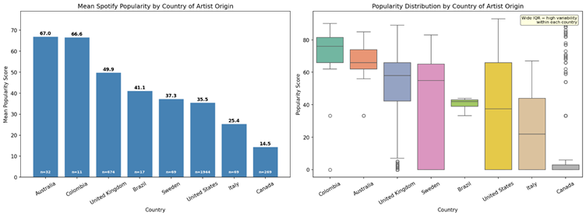
Description: The bar chart shows the mean Spotify popularity score for each country of artist origin, using only countries with at least 10 tracks. The boxplot shows the full distribution of popularity scores per country, which reveals to us both the central tendency median and the variability within each national group.
Interpretation: The bar chart shows that Australian artist achieve the highest mean Spotify popularity at 67.0 and then we have the Colombian artists at 66.6. However, both of these results is based on small samples, n = 32 and n = 11. Australia is primarily represented by AC/DC and Colombia by Shakira, both who have so high stream on Spotify.
On the other hand, we can see that United Kingdom artists have a mean of 49.9 with n = 674 and United States artists have a mean of 35.5 with n = 1,944, which appears to be low for the US, but it is explained by the very high standard deviation 32.3, meaning there is extreme variability between popular modern artists and older artist whose are less actively streamed. Canada shows the lowest at 14.5 and n = 269, because Celine Dion and Bryan Adams, that have more older catalogues that have less modern streaming.
Overall, the country of origin shows some variation in mean scores, but it is not a strong predictor due to the high country variability across all groups.

Q2: Does real world commercial success (claimed record sales) correlate with Spotify popularity Scores?
The variable used to answer this question is claimed_sales Wikipedia and popularity from Spotify.
Intent: This question examines whether an artist’s historical commercial success serves as a reliable predictor of their popularity on Spotify. A strong correlation would suggest commercial dominate artists remain popular on streaming platforms, while a weak one would suggest legacy success does not mean to be a modern one.
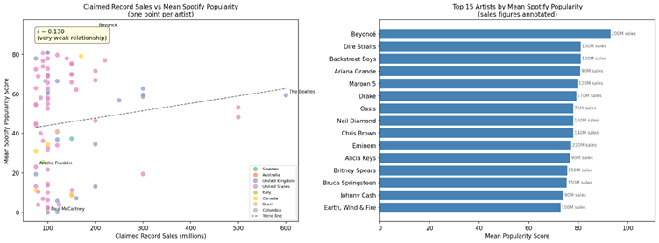
Description: The scatter plot visualises the relationship between claimed sales on the x axis and the mean Spotify popularity on the y axis, with data points coloured by country. A dashed regression line means the overall trend, while the Pearson correlation r is displayed to quantify the relationship. The bar chart ranks the top 15 artists by mean popularity, with their total sales figures annotated for direct comparison.
Interpretation: The Pearson correlation between claimed record sales and mean Spotify popularity is r = 0.13, which represents a very weak positive relationship. The R square value of 0.017 means that if I know an artist's total sales, I can only guess 1.7 % of their Spotify popularity correctly. The scatter plot shows this clearly, Beyonce tops Spotify popularity with a mean of 93.0 despite having 200 million claimed sales, while the Beatles hold the highest sales figure at 600 million yet did not appears on the bar chart and also Eminem have a 220 million and rank lower, this patter repeats across the dataset newer artist such as Taylr Swift, Ariana, and Drake always outperform legendry artists on Spotify regardless of their total sales compare. The finding reveals a shift, artists who built there careers in the digital streaming era have active fan base on platforms like Spotify, while artists who dominated physical media sales in the 20th century have less activity on streaming platforms.
Q3: How do audio features (energy, dancabillity, valence) differ between newer artist and older artist?
Variable used: years_actuve from Wikipedia and energy, dancability, valence from spotify.
Intent: this qyestion investigate whether the length of an artist’s career is related to the audio characteristics of their music. Artist who rose to fame in earlier time and recorded to completely different production technology, and genre than the one used by modern artist. The question divides artists into three career length groups new, that active less than 30 years, and mid career 30 to 50 years and old more than 50 years, and comparing their means energy, dancability, and valence between the groups to see if the era an artist belongs to reflect in how their music sounds.
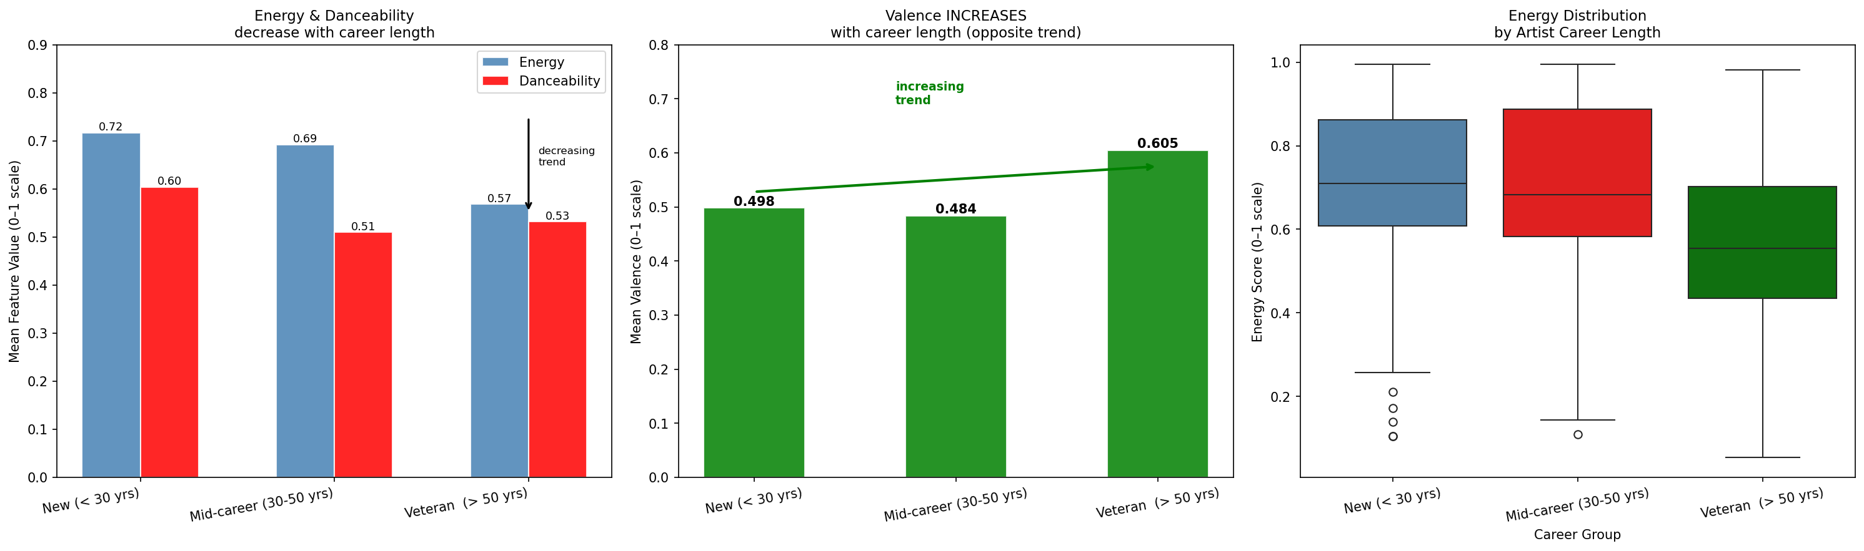
Description: the first plot is grouped bar chart o the mean energy and danceability for each of the three career stages with a down arrow to indicates that energy and danceability decrese from new oto old. The second plot is a bar chart of valence, with and upward arrow, because valence is the opposite direction of energy and dancability and need to be showen separately to avoid hiding this trend. The third plot is a boxplot of energy distribution across the three groups, showing the mean and the full spraed and variability of energy (median) scores within each career stage.
Interpretation: The clustered bar chart reveals a very clear pattern for energy and danceability: modern artists have the highest scores (energy = 0.717, danceability = 0.604), old artists have the lowest (energy = 0.568, danceability = 0.532) and mid-career artists fall in between (energy = 0.692, danceability = 0.510). So as artists age, both energy and danceability decrease, and this is because music production techniques have changed throughout the years - contemporary artists produce songs that are louder, more energetic, and more danceable due to the prevalence of hip-hop, electronic and pop-dance music; whereas veteran artists recorded songs in periods when classic rock, folk and acoustic music were more popular and these genres are lower in energy and danceability. But the valence is the exact opposite and this is the key point in Q3. The youngest artists have the lowest valence (0.498), followed by mid-career artists (0.484) and finally old artists (0.605) - a 0.107 point difference, with veterans scoring higher than new artists. This is the opposite of what we would expect: that older music will be happier and more positive in its emotional colour than newer music. This makes sense because the traditional rock and pop music of artists such as ABBA, The Beatles, and Elton John is based on happy melodies and harmonies, whereas most contemporary genres (hip-hop, alternative, and emo pop) use darker melodies and harmonies. The energy boxplot shows that the difference in energy is not due to outliers - the whole distribution is shifted down from new artists to older. In short, Q3 shows that career length is a significant predictor of audio profile, but that the relationship is more complex than a simple trend - some features go up while others go down, depending on the music of the time.

Q4 Do artists with higher claimed record sales tend to produce faster (higher tempo) music, or does commercial success have no relationship with the speed of music?
Interpretation:
The Pearson correlation between claimed sales and mean tempo is r = -0.020, very nearly zero - claimed sales account for 0.0% of the tempo variation. This suggests that there is no correlation between artist sales and tempo. This is also apparent in the bar chart of mean tempo by sales tier: the Legend tier (350M+ sales) is actually the slowest, at 114.2 BPM, with the fastest being the Mid tier (100-200M sales) at 123.2 BPM, although these differences are very minor and at odds with each other. This lack of correlation makes sense because tempo is more to do with genre and style than sales: both very fast hip-hop and very slow ballads can sell millions of albums.
intent:
This question examines whether artists who had the greatest success in terms (based on total claimed record sales in millions), on average, release faster or slower music on average. Tempo is a measure of the tempo or speed of the music and this question examines if it is associated with an artist's commercial success or if it is independent of success.
Variables used:
claimed_sales (Wikipedia), tempo (Spotify)
Chart type:Scatter plot (to show the relationship between two continuous variables) and
bar chart (to compare mean tempo across sales tiers for a clearer group-level view)
description:
The scatter plot on the left is a point for each artist and their claimed record sales on the x-axis and mean tempo of their tracks on the y-axis. Only the four most artists are shown to prevent crowding. The Pearson r is displayed. The bar chart on the right shows the mean tempo of artists grouped into four sales categories. tempo to check if this effect remains.
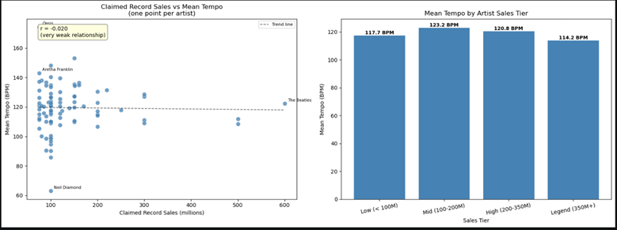
Q5 — Does track duration differ between newer artists and veteran artists — do long-active artists tend to produce shorter or longer songs.
Interpretation:
Mid-career artists (with careers lasting 30-50 years) have the longest tracks (average 3.99 minutes), followed by new artists (average 3.67 minutes) and the shortest tracks are produced by the veterans (average 3.35 minutes). This relationship is not linear (decreasing or increasing with career). The shorter songs produced by veteran artists are likely due to the constraints of the mediums in which they recorded their most popular music: vinyl records had a limited length per side, and radio stations had very specific song format lengths. The longer tracks of mid-career artists, who started their careers in the 1980s and 1990s, likely reflect the opportunity to record longer tracks on album releases, especially within the genres of rock and classic pop. The large standard deviation for veterans (1.11 minutes) reveals considerable diversity in this group (a mix of artists).
Intent:
This question explores whether career span is correlated to average song length. Older artists who became successful in the past were constrained by different factors (number of songs on a vinyl record side, radio format restrictions) than contemporary artists who create music for streaming services with no time limits. This question seeks to test if this impacts the data.
Variables used: duration_sec (Spotify), career_group (derived from years_active)
Chart type: Boxplot (shows the full distribution and spread) and bar chart (shows mean duration per group with exact values)

Description:
The boxplot on the left shows the full distribution of track duration (in minutes) across the three career groups, including the median, interquartile range, and outliers. The bar chart on the right shows the mean duration per group with exact values labelled, making it easy to compare the average track length across career stages.
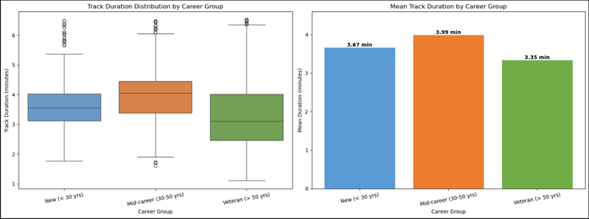
Q6 How do Wikipedia genre labels differ in terms of energy and loudness — do certain genres consistently produce louder and more energetic tracks?
Interpretation:
Hip-hop is the loudest at -4.487 dB, followed by metal, which is the most energetic (mean energy 0.837) and the second loudest (-5.255 dB). The quietest and lowest energy tracks are found in folk and operatic pop. The scatter plot of mean energy vs mean loudness per genre shows a strong positive correlation - genres that are ranked higher in energy also have higher mean loudness. The physical reason for this correlation is that high-energy recordings are mixed and mastered using more distortion, compression and louder volume levels. So the genre label is a useful predictor of energy and loudness - if you know that an artist is labelled as hip-hop or metal you know that their recordings will be louder and more energetic than if they were labelled as folk or classical.
Intent:
This question compares the audio features of genres according to the primary genre label scraped from Wikipedia. Energy is an indication of how active a track is while loudness is an indication of volume in decibels. The way these two similar features vary across genres can tell us whether genre labels provide any useful information about audio features - for instance, are hip-hop and rock more energetic and loud than classical and folk music?
Variables used: primary_genre (derived from genre_wiki), energy, loudness.
Chart type: Grouped bar chart (compares two features across genres side by side) and scatter plot (shows the relationship between energy and loudness per genre)
Description:
The grouped bars chart on the left shows the average energy and normalised loudness for all the genres with 20 or more tracks in the matched data set, ordered by energy least energetic. Loudness is scaled to a 0-1 range to be directly compared with energy on the same axis. The scatter plot on the right has a point for each genre with energy as x and loudness as y (the point is labelled by genre), with the Pearson r between the two measures in the title.
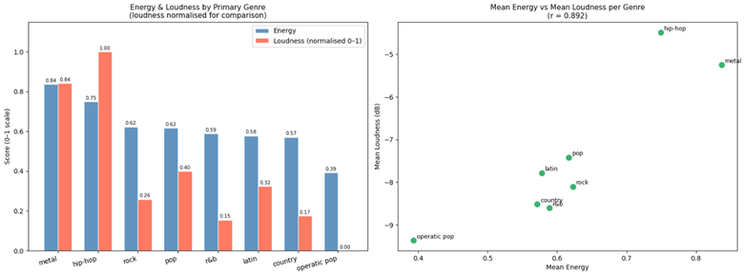
Q7- Is there a correlation between when an artist started and danceability of their songs?
Variables used: start_year (Wikipedia), danceability (Spotify)
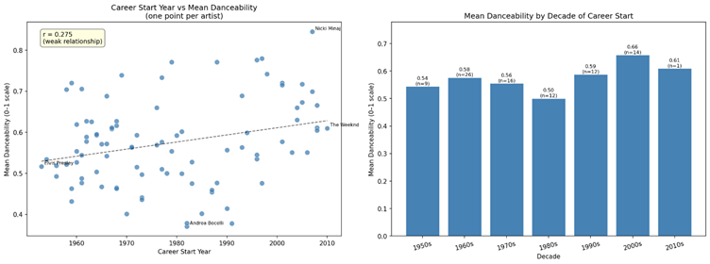
Interpretation:
The Pearson correlation coefficient between start year and mean danceability is r = 0.275, which indicates a weak positive correlation. Those who started their careers more recently have somewhat more danceable music, but start year only accounts for 7.6% of the variance in danceability - there are other factors at work as well. The bar chart of decade shows artists who started their careers in the 2000s have the highest mean danceability (0.659) and those who started in the 1980s have the lowest (0.501). The trend is not completely linear - artists who started in the 1990s (mean = 0.588) have higher danceability than those who started in the 1980s, so the 1980s was particularly unfashionable for danceable music in the careers of major artists. This is probably due to the popularity of rock and arena pop in that decade for the world's highest-selling artists.
Q8 - What are the differences in danceability across Wikipedia genres?
Variables used: primary_genre (from genre_wiki, Wikipedia), danceability (Spotify)

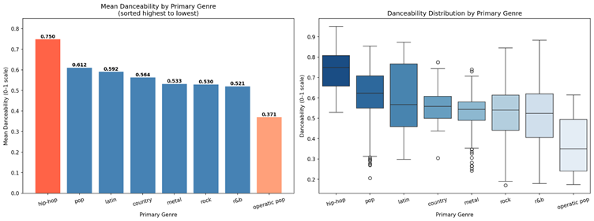
Interpretation:
Hip-hop is the most danceable genre by far with an average danceability of 0.750, 0.220 points higher than the second danceable genre, rock (0.530) and r&b (0.521). The order of danceability is hip-hop, pop, latin, country, metal, rock, r&b and operatic pop (0.371). The difference between the most danceable genre, hip-hop, and the least, operatic pop, is 0.379, which is significant and indicates that genre is indeed a good predictor of danceability. The boxplot also indicates that hip-hop has a relatively small variance (std = 0.126), meaning that hip-hop songs are generally very danceable. Pop has a larger variance (std = 0.179), with a greater range of danceability among pop tracks. This confirms the musical rules of thumb that hip-hop and pop are created especially for rhythmic listening and dancing, while classical and operatic music emphasise melodic and harmonic performance over danceability.
Q9 - Are artists from post 1990 more popular on Spotify than artists from before 1990?
Variables used start_year to generation (Wikipedia), popularity (Spotify)

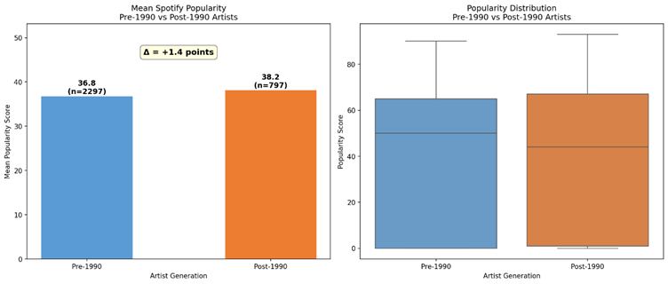
Interpretation:
The average Spotify popularity for Post-1990 artists is 38.18 while it's 36.81 for Pre-1990 artists - a difference of 1.37 points. But the median shows that Pre-1990 artists actually have a higher median of 50.0 than Post-1990 artists (44.0). This indicates that the median Pre-1990 track is more popular on Spotify than the median Post-1990 track, despite the lower mean. The large mean for Post-1990 artists is being skewed up by a few super-popular modern artists, like Beyonce and Ariana Grande. This means that while the average popularity of modern artists is greater due to some artists being highly popular (such as Beyonce, Ariana Grande), the back-catalogues of artists such as Queen, The Rolling Stones, and Elvis Presley are still being streamed and heard by many listeners, so the Pre-1990 median remains high. The means and medians should be taken into account when analysing this finding.

Q10 How does Wikipedia genre label relate to Spotify popularity?
Variable used: primary_genre (from genre_wiki, Wikipedia), popularity (Spotify)

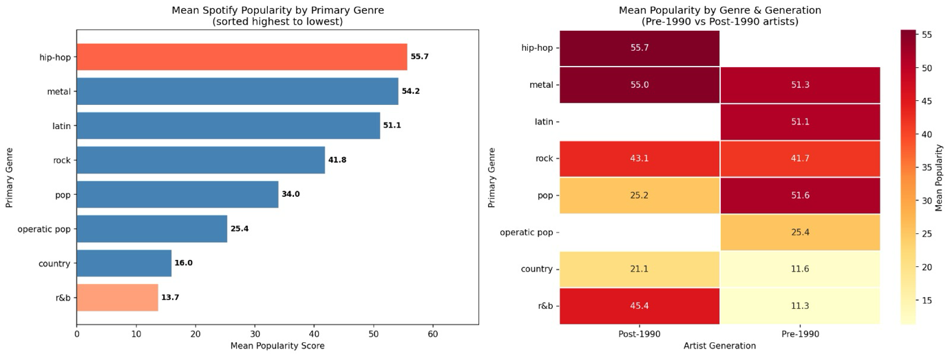

Interpretation: With a popularity at 55.71, Hip-hop artists achieve the highest, and the metal is close to folllow by 54.21, a somewhat surprising finding because metal is often considered a more niche genre in mainstream contexts. Latin artists rank third at 51.09. Rock sits at 41.82, while pop is lower at 33.95, and R&B scores the lowest at 13.72, with country slightly higher at 15.98.
Although maybe only specific artists only drive this high popularity; for instance, like Metallica or AC/DC could contribute to consistently high streaming numbers due to their large and dedicated fan bases.
the generational composition of the dataset might just explain the lower overall popularity of R&B and country. The heat map indeed suggests that earlier (pre-1990) artists in these genres tend to have much lower popularity scores compared to more recent artists, and that pulls down their overall averages. post-1990 R&B artists, In contrast, show considerably higher popularity, indicating that the genre itself is not uniformly low-performing.
pop shows the opposite pattern, and shows pre-1990 artists to have notably higher popularity than post-1990 ones, and that suggests the distribution of artists across time periods significantly affects the mean values.
These patterns indicate that maybe genre characteristics are not the only factors in differences in mean popularity across genres but also the specific artists included and their generational distribution.

Q11 Do veteran artists produce significantly less loud music than newer artists?
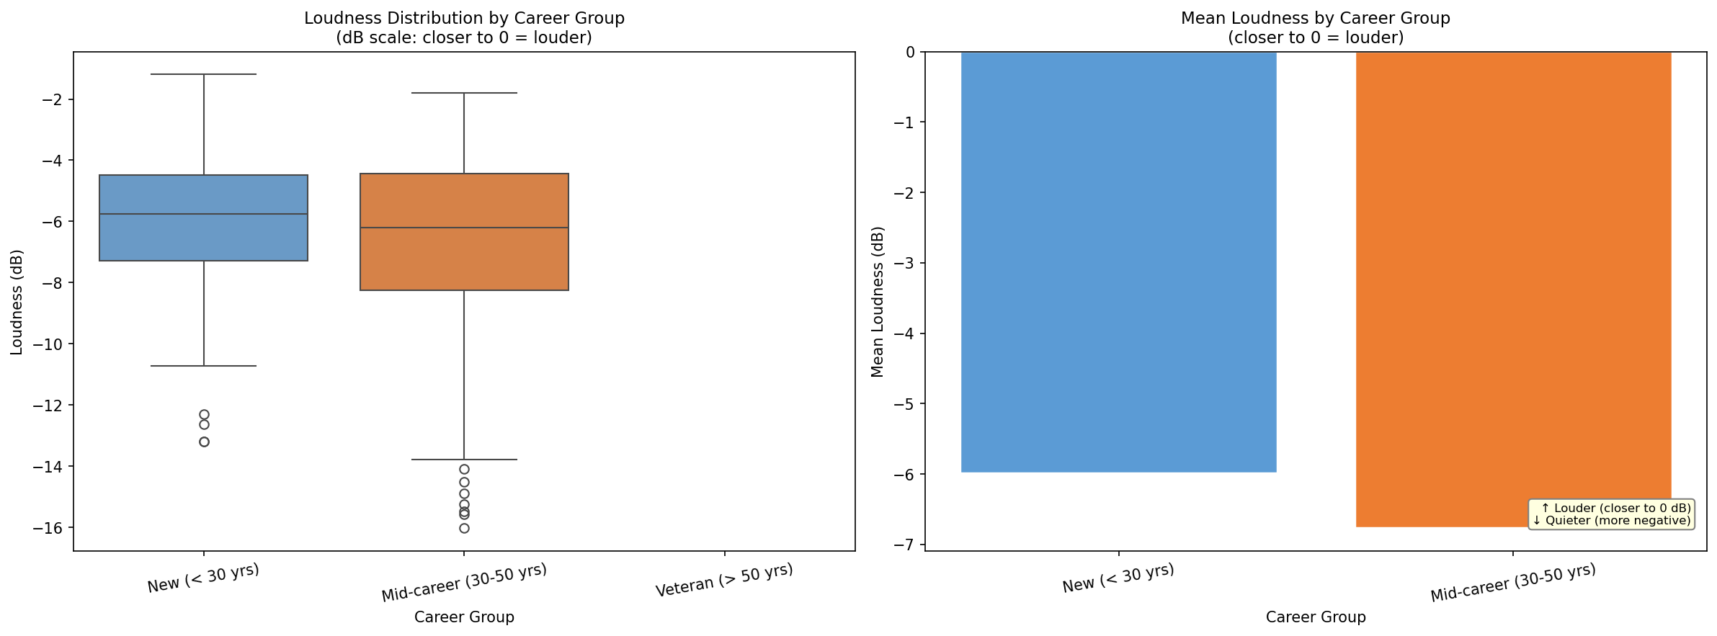

Interpretation: There is a clear and consistent pattern across career groups: newer artists who have been active less than 30 years have a mean loudness of -5.979 dB, mid-career artists average -6.755 dB, and veteran artists (active more than 50 years) average -9.042 dB. As it is clear how decibel scale in negative, values closer to zero represent louder recordings , the record shows newer artists are 3.06 dB louder than veteran artists averagely. "loudness war" in the music industry is validated by these results, the decades-long trend of recordings being mastered progressively louder for multiple reasons. The boxplot actually confirms that this is a consistent trend and not driven by outliers, the entire distribution shifts toward zero from veterans to newer artists.

Q12 Does Wikipedia genre label predict how instrumental or vocal-heavy a track is?

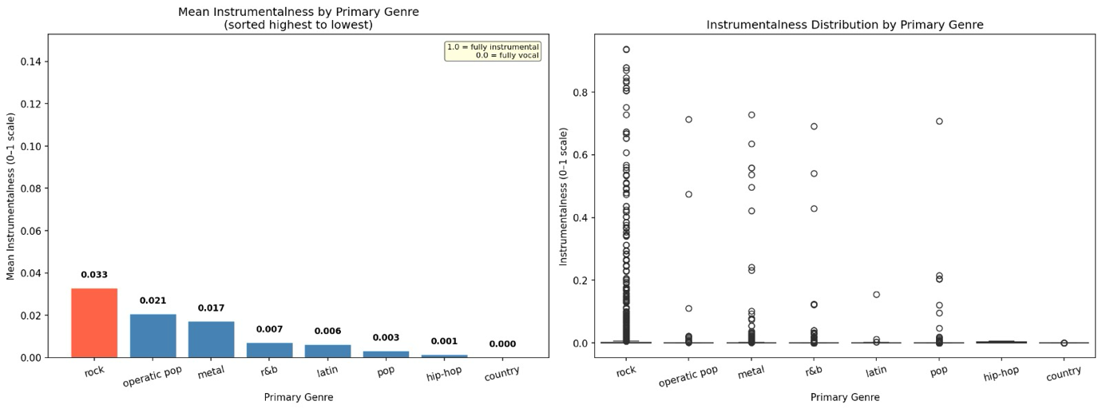

Interpretation:
The instrumentalness values across all genres are extremely low and clustered near zero. Rock leads with a mean of 0.0329, followed by operatic pop at 0.0206 and metal at 0.0172. Pop, r&b, and hip-hop have means below 0.005. All genre medians are exactly 0.0, meaning that the majority of tracks in every genre are almost entirely vocal-dominated with no significant instrumental content. While rock does score slightly higher than pop or hip-hop, the absolute differences are very small, the gap between the highest (rock at 0.033) and the lowest (hip-hop at 0.001) is only 0.032. This means that for this particular dataset of world-famous artists, instrumentalness is not a useful differentiator between genres. Most of the 128 Wikipedia artists, regardless of genre, produce vocal-centred commercial music. This is an honest negative finding, genre label does not meaningfully predict instrumentalness in this dataset.

5. Hypothesis Testing
5.1 Hypothesis Formulation
H0 null | Pre 1990 and post 1990 artists have the same mean spotify popularity, any observed difference is due to random chances
H1 Alternative | Post 1990 artists have a significantly higher mean spotify popularity then prew 1990
Test used | Independent samples t-test (Welch’s, equal_var=false)
Significant level | Alpha = 0.05
Why t-test | We are comparing means of two independent groups, popularity is a continues variable

5.2 Manual Calculation
before verifying with scipy the t-statistic had to be calculated manually. The formula for an independent samples t-test is: t = (mean1 - mean2) divided by the square root of (s1 squared over n1 plus s2 squared over n2). Using the group values: Post-1990 mean = 38.184, std = 32.580, n = 797; Pre-1990 mean = 36.814, std = 31.332, n = 2297. To calculate the standard error of the difference as the square root of (32.580 squared over 797 plus 31.332 squared over 2297), with standard error of 1.3264. The t-statistic was then (38.184 minus 36.814) divided by 1.3264, which equals 1.0331. And calculating the degrees of freedom using Welch's approximation, giving df = 1340.98.
5.3 Results
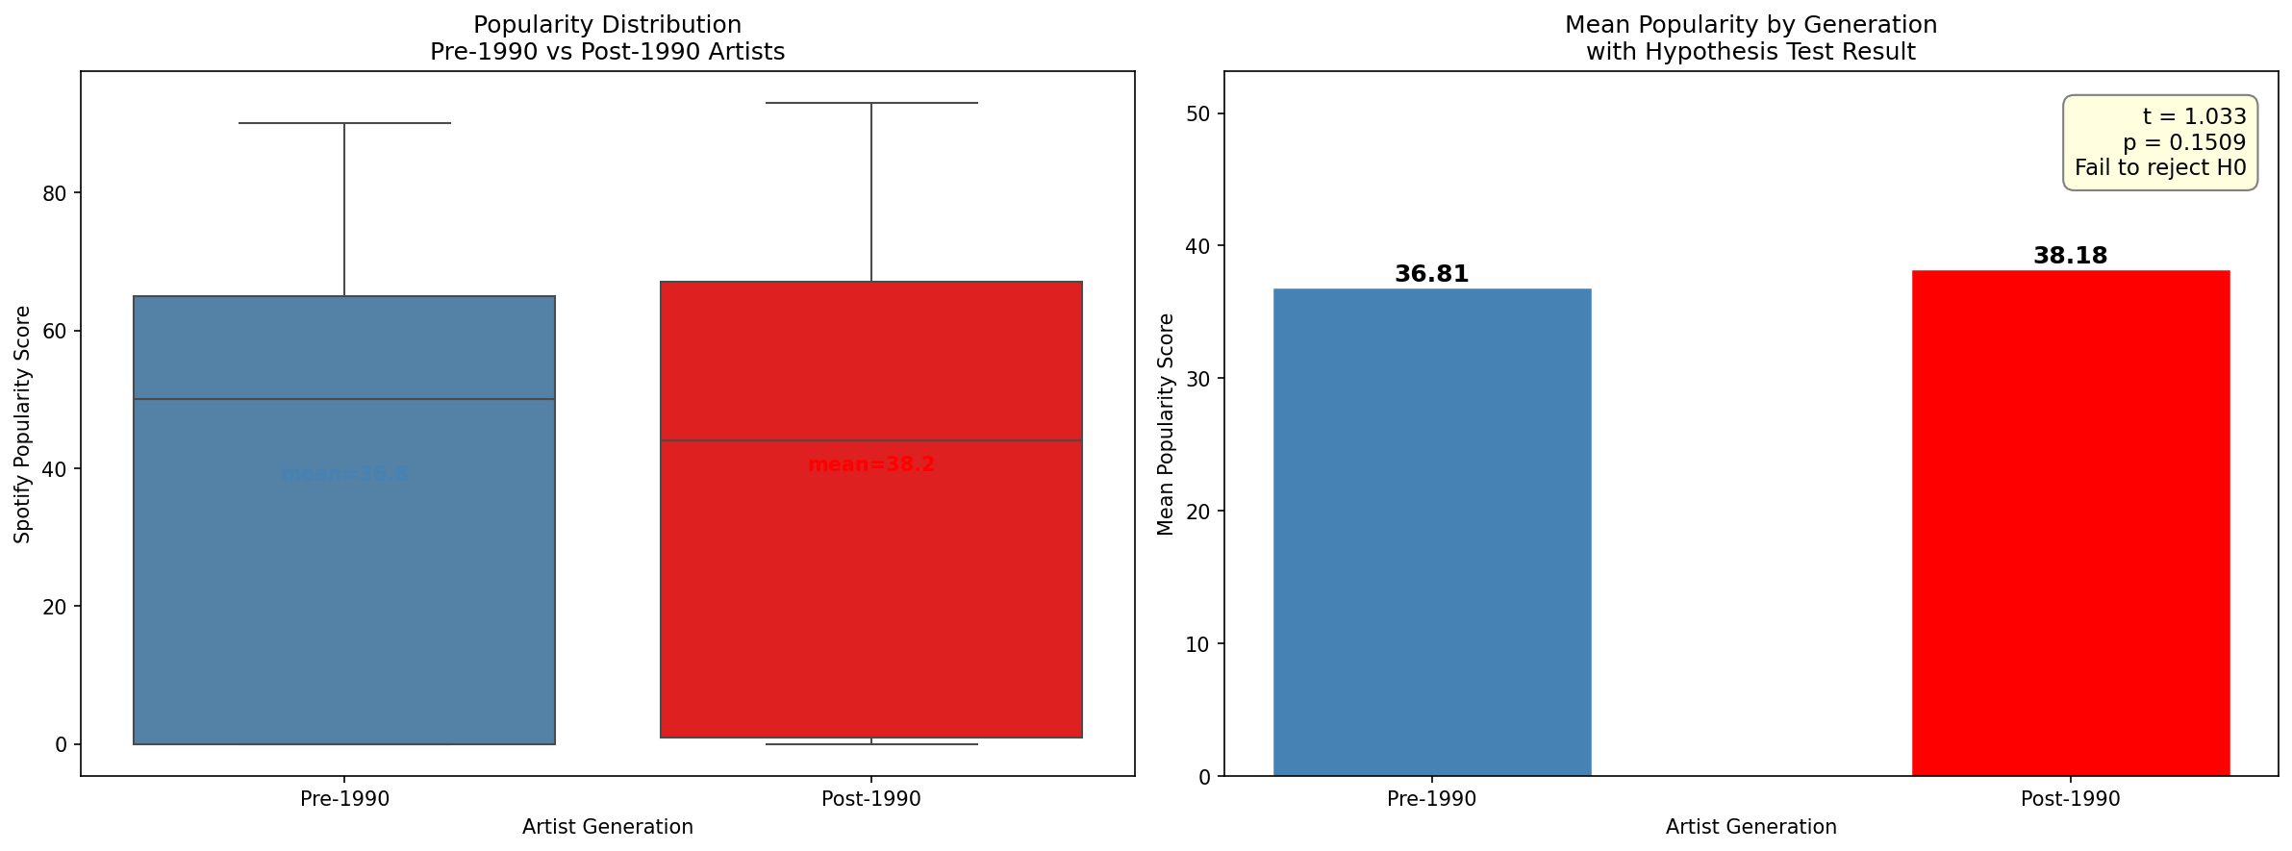

Pre 1990 mean popularity | 36.814 (n = 2.297, std = 31.332)
Post 1990 mean popularity | 38.184 (n = 797, std = 32.580)
Observed difference | 1.370
T-statistics man | 1.0331
T-statistics scipy | 1.0331
P value | 0.1509
Decision (alph = 0.05) | P = 0.1509 > 0.05 fail to reject H0

5.4 Conclusion
The independent samples t-test did in fact produce a t-statistic of 1.033 and a p-value of 0.151. And as the significance level of 0.05, that’s greater than the p-value of 0.151. we fail to reject the null hypothesis. Ergo it is not statistically feasible proof that Post-1990 artists have a significantly higher mean Spotify popularity than Pre-1990 artists. The difference in popularity points is1.37 between the two groups, albeit present, it is too small relative to the variability within each group (standard deviations of 32.6 and 31.3) to be considered statistically significant. This is a valid and honest scientific finding and it tells us that the generation an artist belongs to alone is not a reliable predictor of their Spotify popularity once the large variability within each generation is accounted for. As noted in Q9, some Pre-1990 artists maintain very high streaming numbers on Spotify, and some Post-1990 artists have low popularity scores, which explains why the difference between group means is not statistically meaningful.

6. Overall Discussion:
Hazem:
My three project 2 questions collectively explored how the external factors of an artist's country of origin, commercial success and career duration are related to the music itself and its performance on Spotify. What the three questions boil down to is that Spotify popularity is less related to how well known an artist is in "traditional" fame and more related to how recently they have gained popularity. There was little to no correlation with commercial history, high variance in popularity by country, and a clear advantage to newer artists in terms of energy and danceability, with an interesting flip-flop for valence. These results indicate that Spotify favours artists whose music was released in the streaming age and whose fans are Spotify users, not necessarily traditional artists who have been successful over time.

Andrew:
1 is commercial success related to career stage, 2 is commercial success related to musical features (tempo, track duration and genre profiles), and 3 is career stage related to musical features? The most important result is that commercial success (measured by claimed sales) is not related to tempo (r = -0.020), showing that tempo is an artistic/genre feature, not a commercial one. The track duration analysis found that mid-career artists have the longest pieces, debunking a simplistic idea that older artists would write longer pieces; rather, this is the result of the flexibility of the album in the 1980s and 1990s. The genre energy and loudness analysis found that genre is indeed a good indicator of both features, with metal and hip-hop being louder and more energetic than folk and classical genres.

Islam:
The three questions examined the connections between the era in which an artist's career took place and the danceability and popularity of their songs. The overall takeaway is that while there is a correlation between era and danceability (r = 0.275, weak) genre is a much stronger predictor - the danceability mean of hip-hop (0.750) is way ahead of any other genre. The generational analysis in Q9 was more complicated: while the mean popularity of Post-1990 is slightly higher, the median of Pre-1990 is higher, which means that while the classics have steady streaming data, a few super-stars skew the Post-1990 mean. The bottom line is that musical era and genre are intertwined, and neither is a reliable predictor of success in the modern music streaming environment.

Omar:

the esteemed Omar AbdelRahman investigated with his three questions genre-level patterns in Spotify popularity, loudness evolution across generations, and instrumentalness by genre. the loudness war validation was a striking finding; a clear, consistent 3 dB increase in loudness from veterans to newer artists confirms that modern music production has systematically become louder over time. The genre popularity analysis produced a surprising result: metal ranked as the second most popular genre after hip-hop, driven by the dedicated streaming audiences of artists like Metallica and AC/DC. The instrumentalness analysis delivered an honest negative finding,all genres cluster near zero, meaning that vocal-centred commercial music is the norm across all artist types in this dataset, and genre label does not meaningfully predict how instrumental a track is.

